Edvard Munch (1863 Løten, Norway –1944, Ekely/Oslo)
was a Norwegian painter, printmaker and sculptor, who experimented with photography and film. He belongs to the main forerunners of EXPRESSIONISM and his painting The Scream (1893) became a universal icon of existentialist fear.
Career
In 1879 Munch enrolled at a technical college and in 1881 at the Royal School of Art and Design of Christiania, where he took lessons in freehand drawing and modelling. In 1882 he was supervised by the naturalistic painter Christian Krohg and in 1883 he held his first public exhibition. In 1885 Munch travelled to Paris; some influences of French art were recognizable in the works he presented at his first one-man show in Christiania in 1889. The recognition he received with this exhibition gained him a state scholarship to Paris for the period 1889-92. There he studied under French painter Léon Bonnat and saw works by Paul Gauguin, Vincent van Gogh, Henri Toulouse-Lautrec and James Whistler. (Post-)IMPRESSIONISM and synthetism influenced his work of this period.
In 1889 Munch painted a portrait of Hans Jæger, leader of the Christiania Bohème and since then he belonged to its wider circle. In his symbolic paintings and literary diaries he followed the dictum of this anarchist writer ‘You should write your life’. Traumatic memories of illness and death became the leitmotif of his painting, which is reflected e.g. in his first experimental masterpiece The Sick Child (1886). His ‘soul paintings’ corresponded with the theory of the ‘naked soul’ by Stanisław Przybyszewski, who became his first monographer in 1893. Munch met him, August Strindberg and Hendrik Ibsen in Berlin after his first exhibition there in 1892, which caused the ‘Munch scandal’. In contrast to the predominant negative criticism, Przybyszewski prised his Frieze of Life (including e.g. The Kiss and Vampire). Referring to the Frieze, he invented the first theory of proto-expressionism and contributed to Munch’s success in Central Europe.
In 1894 Munch started experimenting with etching, lithography and woodcut, becoming a master of these reproductive techniques; he tended to concentrate on the repetition of existential themes. After he settled in Paris in 1896 graphic depictions of modern popular culture became his main focus. At the turn of the century, he combined in his paintings metaphysical ideas with a symbolical usage of colour and composition.
With his 1902 show at the Berliner Secession and his 1905 one-man exhibition in Prague organized by the Mánes Union of Fine Arts, Munch gradually became an established painter with patrons and dealers in Germany, e.g. Max Linde, Bruno Cassirer, Eberhard von Bodenhausen and Harry Graf Kessler. He painted portraits of his supporters and of well-known contemporaries such as Friedrich Nietzsche (1905/06 the only one painted from photographs). In 1906 he designed the sets for Max Reinhardt’s theatre. His new themes were Bathing Men (1907-08) and from 1916 on as he mostly lived in isolation in Ekely near Oslo nature, nudes and numerous self-portraits.
Legacy
In 1908 when Munch stayed at a clinic in Copenhagen because of a nervous breakdown after years of personal and artistic struggle, he was awarded the Royal Order of St. Olav ‘for services in art’. In 1909 he returned to Norway where he showed three hundred of his works in a retrospective exhibition. He won the competition for the monumental decorations of the Aula of the Christiania/Oslo University, which he completed in 1916. His first American exhibition was held in New York in 1912. Munch’s most important exhibitions were shown in Germany – the Sonderbund in Cologne in 1912 and a comprehensive show at the Nationalgalerie in Berlin in 1927. In 1937 his works were denounced as ‘degenerate art’ and removed from German museums. Munch left the majority of his works to the city of Oslo, which opened a museum in his honour in 1963.
References and further readings:
Arne Eggum, Edvard Munch: Paintings, sketches, and studies, New York: C.N. Potter, 1984.
Mai Britt Guleng, eMunch.no – Text and Image, Oslo: Munch Museum, 2011.
Reinhold Heller, Munch. His life and work, London: Murray, 1984.
Gustav Schiefler, Verzeichnis des graphischen Werks Edvard Munchs bis 1906, Berlin: Bruno Cassirer, 1907.
Gustav Schiefler, Edvard Munch. Das graphische Werk 1906-1926, Berlin: Euphorion, 1928.
Gerd Woll (ed), Edvard Munch: Complete Paintings, London/New York: Thames and Hudson, 2009. (Volume I: 1880-1897, Volume II: 1898-1908, Volume III: 1909-1920, Volume IV: 1921-1944).
Gerd Woll, Edvard Munch: The complete graphic works (revised edition), London: Wilson Publishers, 2012.

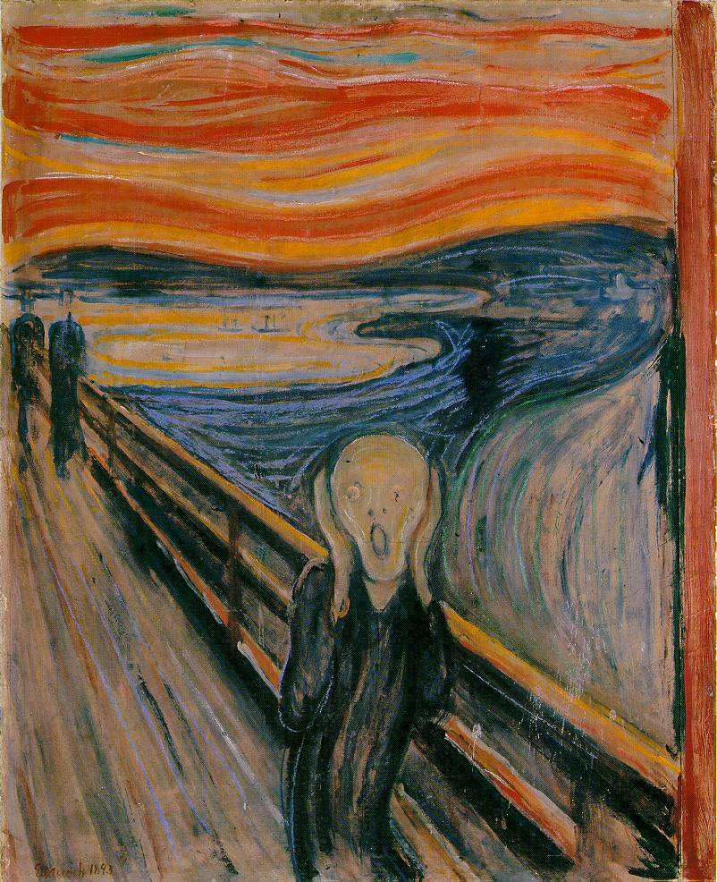
Suggested images:
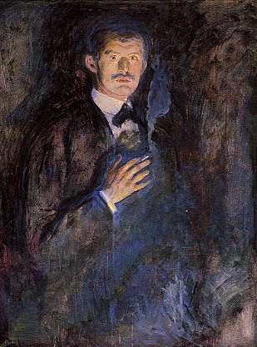
1. Edvard Munch, The Scream, 1893; Casein/waxed crayon and tempera on paper (cardboard), National Gallery, Oslo http://www.ibiblio.org/wm/paint/auth/munch/munch.scream2.jpg
2. Edvard Munch, Self-Portrait with Burning Cigarette, 1895, oil on canvas, National Gallery, Oslo
http://www.edvard-munch.com/Paintings/self/self_cigarette_3.jpg
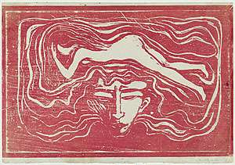
3. Edvard Munch, In man's brain, 1897, woodcut, National Gallery of Australia
http://cs.nga.gov.au/Detail.cfm?IRN=626
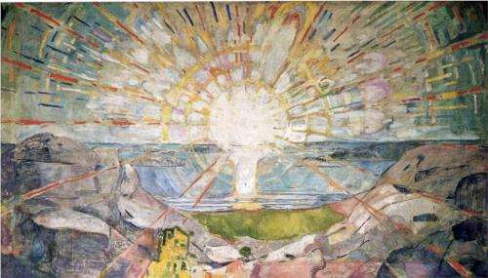
4. Edvard Munch, The Sun, oil on canvas, The Oslo University, Oslo, Norway
http://www.wikipaintings.org/en/edvard-munch/the-sun-1916
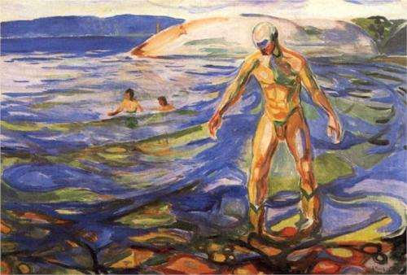
5. Edvard Munch, Bathing Man, 1918, oil on canvas, The Munch Museum, Oslo http://www.wikipaintings.org/en/edvard-munch/bathing-man-1918

